# Installation

OS: Centos 7

1 master node

2 workers node

sed -i s/'PermitRootLogin no'/'PermitRootLogin yes'/g /etc/ssh/sshd_config;

sed -i s/'PasswordAuthentication no'/'PasswordAuthentication yes'/g /etc/ssh/sshd_config;

sed -i s/'ChallengeResponseAuthentication no'/'ChallengeResponseAuthentication yes'/g /etc/ssh/sshd_config;

systemctl restart sshd

sed -i s/SELINUX=enforcing/SELINUX=disabled/g /etc/selinux/config

setenforce 0

getenforce

systemctl disable firewalld; systemctl stop firewalld; systemctl status firewalld

yum install wget git –y

Password less

ssh-keygen

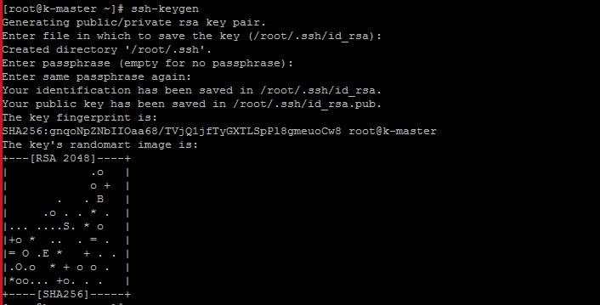

ssh-copy-id -i localhost

ssh-copy-id -i worker1

ssh-copy-id -i worker2

To enable fingerprint

ssh k-master

ssh k-worker

ssh k-worker2

cd /root/

git clone https://github.com/bswsahoo11111/kubernets-install- ansible.git

cd /root/kubernets-install-ansible/kubernetes-and-ansible/centos

vim hosts

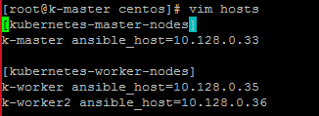

vim env_variables

(change ad_addr🡺 would be master node ip)

Keep cid_v as it is, don’t need to change

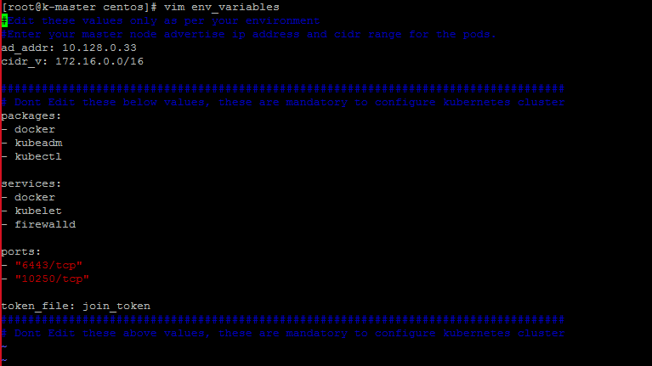

Install ansible on master node

yum install ansible –y

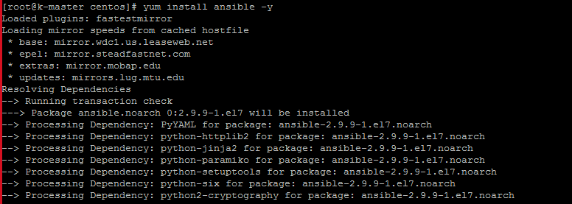

Run below yml

ansible-playbook settingup_kubernetes_cluster.yml

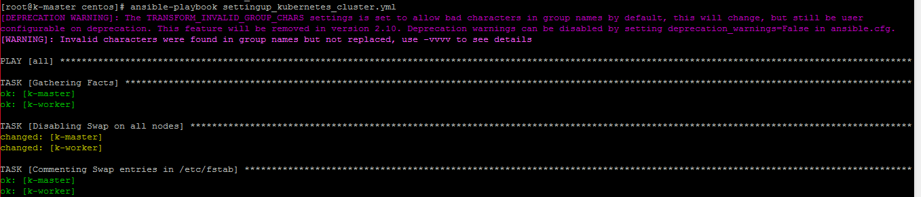

kubectl get nodes

ansible-playbook join_kubernetes_workers_nodes.yml

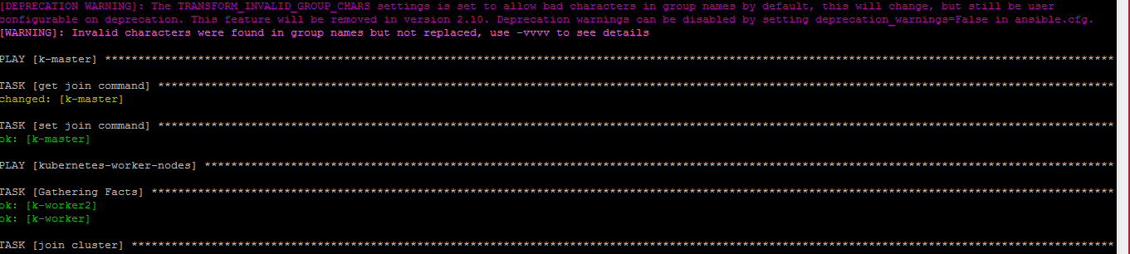

kubectl get nodes

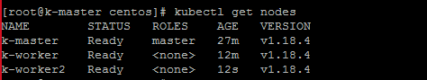

# Reset

cd kubernets-install-ansible/kubernetes-and-ansible/centos

ansible-playbook reset_kubernet.yml

